RIPv2 Routing Information Protocol

Create a topology as illustrate in following figure or download this pre-created topology.

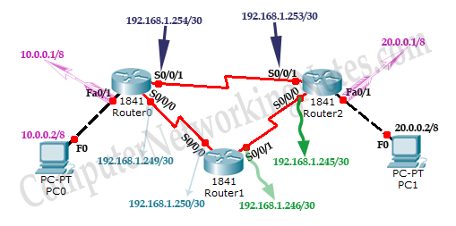

|  |  |  |  |
| --- | --- | --- | --- |
| Device | Interface | IP Configuration | Connected with |
| PC0 | Fast Ethernet | 10.0.0.2/8 | Router0’s Fa0/1 |
| Router0 | Fa0/1 | 10.0.0.1/8 | PC0’s Fast Ethernet |
| Router0 | S0/0/1 | 192.168.1.254/30 | Router2’s S0/0/1 |
| Router0 | S0/0/0 | 192.168.1.249/30 | Router1’s S0/0/0 |
| Router1 | S0/0/0 | 192.168.1.250/30 | Router0’s S0/0/0 |
| Router1 | S0/0/1 | 192.168.1.246/30 | Router2’s S0/0/0 |
| Router2 | S0/0/0 | 192.168.1.245/30 | Router1’s S0/0/1 |
| Router2 | S0/0/1 | 192.168.1.253/30 | Router0’s S0/0/1 |
| Router2 | Fa0/1 | 20.0.0.1/30 | PC1’s Fast Ethernet |
| PC1 | Fast Ethernet | 20.0.0.2/30 | Router2’s Fa0/1 |

**Assign IP address to PCs**

Double click **PC0** and click **Desktop** menu item and click **IP Configuration**. Assign IP address 10.0.0.2/8 to PC0.

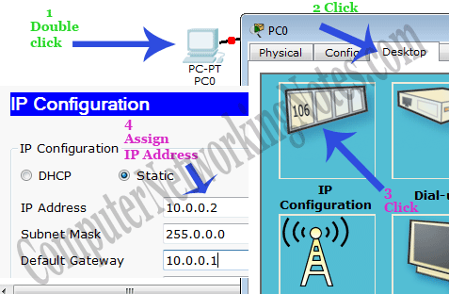

Repeat same process for PC1 and assign IP address 20.0.0.2/8.

**Assign IP address to interfaces of routers**

Double click **Router0** and click **CLI** and press **Enter key** to access the command prompt of **Router0**.

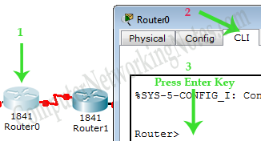

Three interfaces *FastEthernet0/0*, *Serial0/0/0* and *Serial0/0/1* of **Router0** are used in this topology. By default interfaces on router are remain administratively down during the start up.

We need to configure IP address and other parameters on interfaces before we could actually use them for routing. Interface mode is used to assign IP address and other parameters. Interface mode can be accessed from global configuration mode. Following commands are used to access the global configuration mode.

Router>enable

Router#configure terminal

Enter configuration commands, one per line. End with CNTL/Z.

Router(config)#

From global configuration mode we can enter in interface mode. From there we can configure the interface. Following commands will assign IP address on FastEthernet0/0.

Router(config)#interface fastEthernet 0/0

Router(config-if)#ip address 10.0.0.1 255.0.0.0

Router(config-if)#no shutdown

Router(config-if)#exit

Router(config)#

**interface *fastEthernet 0/0*** command is used to enter in interface mode.

**ip address *10.0.0.1 255.0.0.0*** command will assign IP address to interface.

**no shutdown** command will bring the interface up.

**exit** command is used to return in global configuration mode.

Serial interface needs two additional parameters **clock rate** and **bandwidth**. Every serial cable has two ends DTE and DCE. These parameters are always configured at DCE end.

We can use **show controllers interface** command from privilege mode to check the cable’s end.

Router#show controllers serial 0/0/0

Interface Serial0/0/0

Hardware is PowerQUICC MPC860

DCE V.35, clock rate 2000000

[Output omitted]

Fourth line of output confirms that DCE end of serial cable is attached. If you see DTE here instead of DCE skip these parameters.

Now we have necessary information let’s assign IP address to serial interface.

Router#configure terminal

Enter configuration commands, one per line. End with CNTL/Z.

Router(config)#interface serial 0/0/0

Router(config-if)#ip address 192.168.1.249 255.255.255.252

Router(config-if)#clock rate 64000

Router(config-if)#bandwidth 64

Router(config-if)#no shutdown

Router(config-if)#exit

Router(config)#interface serial 0/0/1

Router(config-if)#ip address 192.168.1.254 255.255.255.252

Router(config-if)#clock rate 64000

Router(config-if)#bandwidth 64

Router(config-if)#no shutdown

Router(config-if)#exit

Router(config)#

**Router#configure terminal** Command is used to enter in global configuration mode.

**Router(config)#interface *serial 0/0/0*** Command is used to enter in interface mode.

**Router(config-if)#ip address *192.168.1.249 255.255.255.252*** Command assigns IP address to interface. For serial link we usually use IP address from /30 subnet.

**Router(config-if)#clock rate *64000*** And **Router(config-if)#bandwidth *64*** In real life environment these parameters control the data flow between serial links and need to be set at service providers end. In lab environment we need not to worry about these values. We can use these values.

**Router(config-if)#no shutdown** Command brings interface up.

**Router(config-if)#exit** Command is used to return in global configuration mode.

We will use same commands to assign IP addresses on interfaces of remaining routers. We need to provided clock rate and bandwidth only on DCE side of serial interface. Following command will assign IP addresses on interface of Router1.

###### Router1

Router>enable

Router#configure terminal

Enter configuration commands, one per line. End with CNTL/Z.

Router(config)#interface serial 0/0/0

Router(config-if)#ip address 192.168.1.250 255.255.255.252

Router(config-if)#no shutdown

Router(config-if)#exit

Router(config)#interface serial 0/0/1

Router(config-if)#ip address 192.168.1.246 255.255.255.252

Router(config-if)#clock rate 64000

Router(config-if)#bandwidth 64

Router(config-if)#no shutdown

Router(config-if)#exit

Use same commands to assign IP addresses on interfaces of Router2.

###### Router2

Router>enable

Router#configure terminal

Enter configuration commands, one per line. End with CNTL/Z.

Router(config)#interface fastEthernet 0/0

Router(config-if)#ip address 20.0.0.1 255.0.0.0

Router(config-if)#no shutdown

Router(config-if)#exit

Router(config)#interface serial 0/0/0

Router(config-if)#ip address 192.168.1.245 255.255.255.252

Router(config-if)#no shutdown

Router(config-if)#exit

Router(config)#interface serial 0/0/1

Router(config-if)#ip address 192.168.1.253 255.255.255.252

Router(config-if)#no shutdown

Router(config-if)#exit

Great job we have finished our half journey.To be on same page we have uploaded our practice topology with IP configuration. You can download it form here.

Now routers have information about the networks that they have on their own interfaces. Routers will not exchange this information between them on their own. We need to implement RIP routing protocol that will insist them to share this information.

### Configure RIP routing protocol

Configuration of RIP protocol is much easier than you think. It requires only two steps to configure the RIP routing.

* Enable RIP routing protocol from global configuration mode.
* Tell RIP routing protocol which networks you want to advertise.

Let’s configure it in Router0

###### Router0

Router0(config)#router rip

Router0(config-router)# network 10.0.0.0

Router0(config-router)# network 192.168.1.252

Router0(config-router)# network 192.168.1.248

**router rip** command tell router to enable the RIP routing protocol.

**network** command allows us to specify the networks which we want to advertise. We only need to specify the networks which are directly connected with the router.

That’s all we need to configure the RIP. Follow same steps on remaining routers.

###### Router1

Router1(config)#router rip

Router1(config-router)# network 192.168.1.244

Router1(config-router)# network 192.168.1.248

###### Router2

Router2(config)#router rip

Router2(config-router)# network 20.0.0.0

Router2(config-router)# network 192.168.1.252

Router2(config-router)# network 192.168.1.244

That’s it. Our network is ready to take the advantage of RIP routing. To verify the setup we will use ping command. ping command is used to test the connectivity between two devices.

Access the command prompt of **PC1** and use *ping* command to test the connectivity from **PC0**.

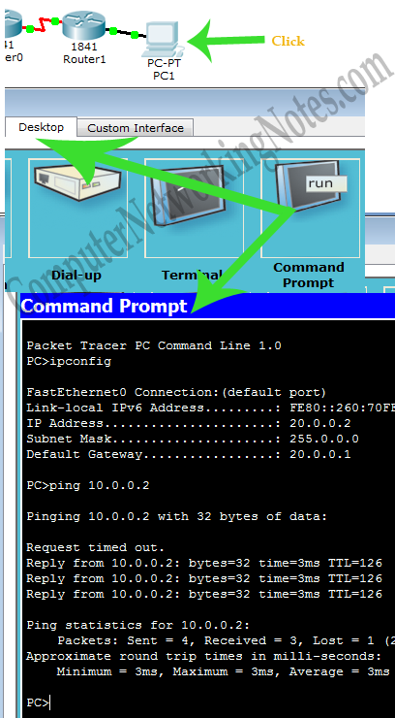

Good going we have successfully implemented RIP routing in our network. For cross check we have uploaded a configured topology on our server. You can download and use that if not getting same output.

RIP protocol automatically manage all routes for us. If one route goes down, it automatically switches to another available. To explain this process more clearly we have added one more route in our network.

Currently there are two routes between PC0 and PC1.

**Route 1**

PC0 [Source / destination – 10.0.0.2] <==> Router0 [FastEthernet0/1 – 10.0.0.1] <==> Router0 [Serial0/0/1 – 192.168.1.254] <==> Router2 [Serial 0/0/1 – 192.168.1.253] <==> Router2 [FastEthernet0/0 – 20.0.0.1] <==> PC1 [Destination /source – 20.0.0.2]

**Route 2**

PC0 [Source / destination – 10.0.0.2] <==> Router0 [FastEthernet0/1 – 10.0.0.1] <==> Router0 [Serial0/0/0 – 192.168.1.249] <==> Router1 [Serial 0/0/0 – 192.168.1.250] <==> Router1 [Serial 0/0/1 – 192.168.1.246] <==> Router2 [Serial 0/0/0 – 192.168.1.245] <==> Router2 [FastEthernet0/0 – 20.0.0.1] <==> PC1 [Destination /source – 20.0.0.2]

By default RIP will use the route that has low hops counts between source and destination. In our network route1 has low hops counts, so it will be selected. We can use *tracert* command to verify it.

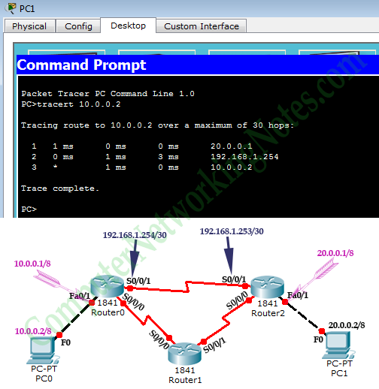

Now suppose route1 is down. We can simulate this situation by removing the cable attached between **Router0 [s0/0/1]** and **Router2 [s0/0/1]**.

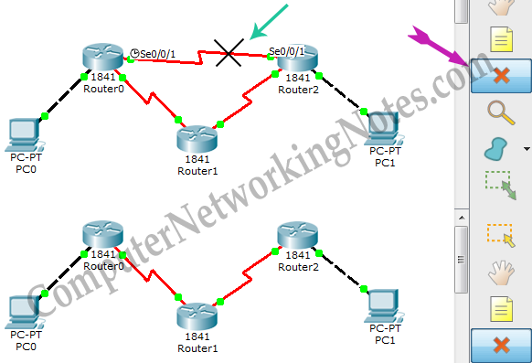

Okay our primary route went down. What will be happen now?

So far we are running RIP routing protocol and have another route to destination, there is no need to worry. RIP will automatically reroute the traffic. Use ***tracert*** command again to see the magic of dynamic routing.

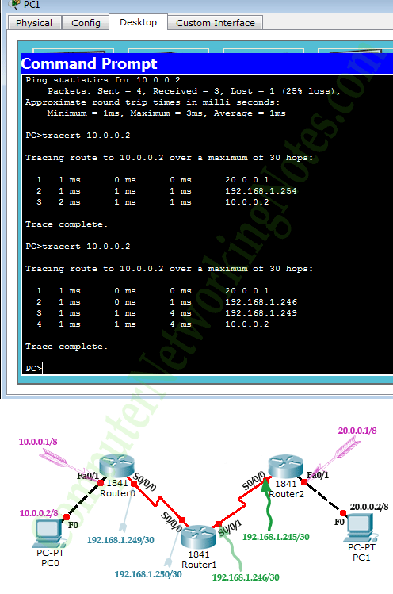

### RIP Routing protocol configuration commands summary

|  |  |
| --- | --- |
| Command | Description |
| Router(config)#router rip | Enable RIP routing protocol |
| Router(config-router)#network a.b.c.d | Add a.b.c.d network in RIP routing advertisement |
| Router(config-router)#no network a.b.c.d | Remove a.b.c.d network from RIP routing advertisement |
| Router(config-router)#version 1 | Enable RIP routing protocol version one ( default) |
| Router(config-router)#version 2 | Enable RIP routing protocol version two |
| Router(config-router)#no auto-summary | By default RIPv2 automatically summarize networks in their default classful boundary. This command will turn it off. |
| Router(config-router)#passive-interface s0/0/0 | RIP will not broadcast routing update from this interface |
| Router(config-router)#no ip split-horizon | Disable split horizon ( Enable by default ) |
| Router(config-router)#ip split-horizon | Enable spilt horizon |
| Router(config-router)#timers basic 30 90 180 270 360 | Allow us to set RIP timer in seconds. 30 (routing update), 90 (invalid timer), 180 ( Hold timer), 270 (Flush timer), 360 (sleep timer) |
| Router(config)#no router rip | Disable RIP routing protocol |
| Router#debug ip rip | Used for troubleshooting. Allow us to view all RIP related activity in real time. |
| Router#show ip rip database | Display RIP database including routes |